**Krishnamoorthy.N IT18144772**

**Schedule Management**

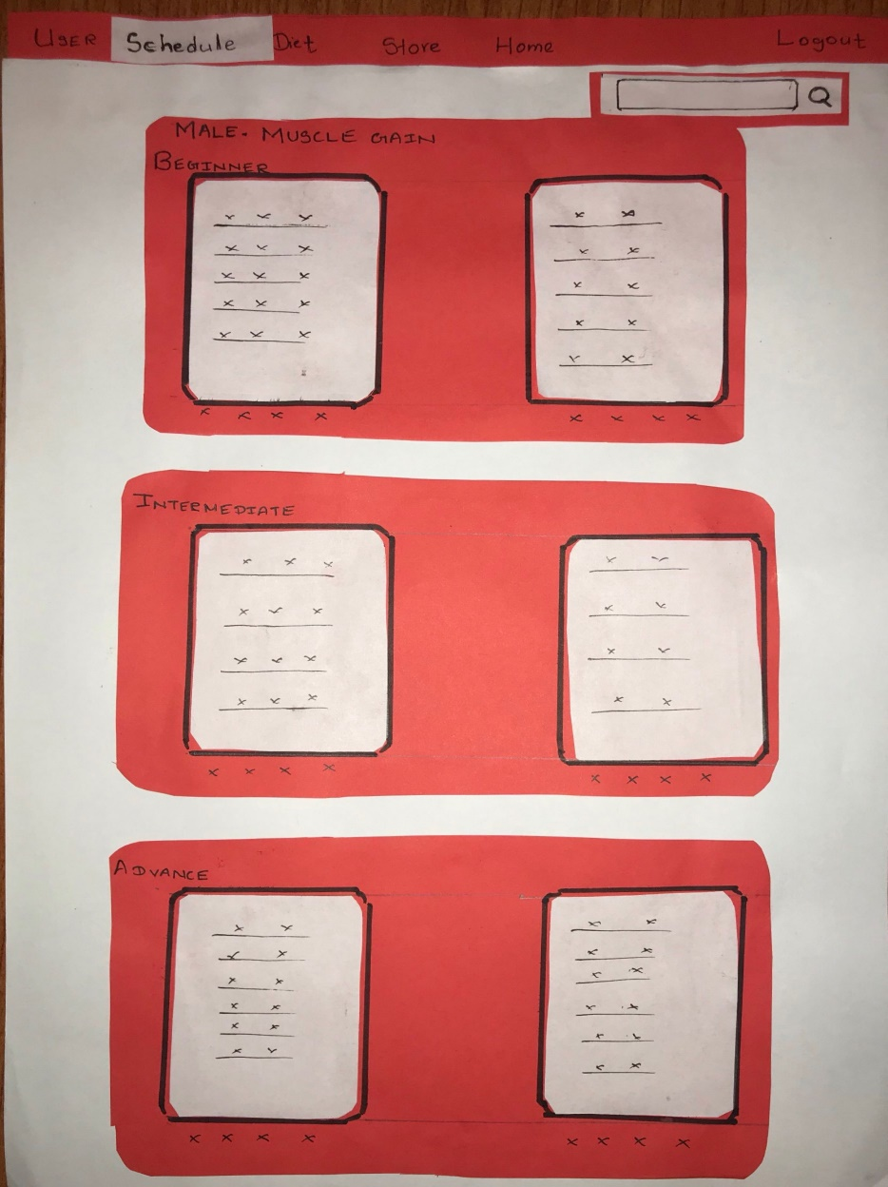

Under this UI we are suggested with schedule types According to the **Gender** of the Member and the **Category** he/she has selected when signing up with the system. The level of schedules suggested are

* Beginner
* Intermediate
* Advance

When customer selects a schedule he will be assigned with the selected schedule as his workout plan.

If the customer completes his/her schedule the customer is suggested to select the same schedule or change the schedule. When changing the schedule the Same UI is displayed according to the selected category by the a member.

Along side this page there is a search bar in which we can search the schedules.

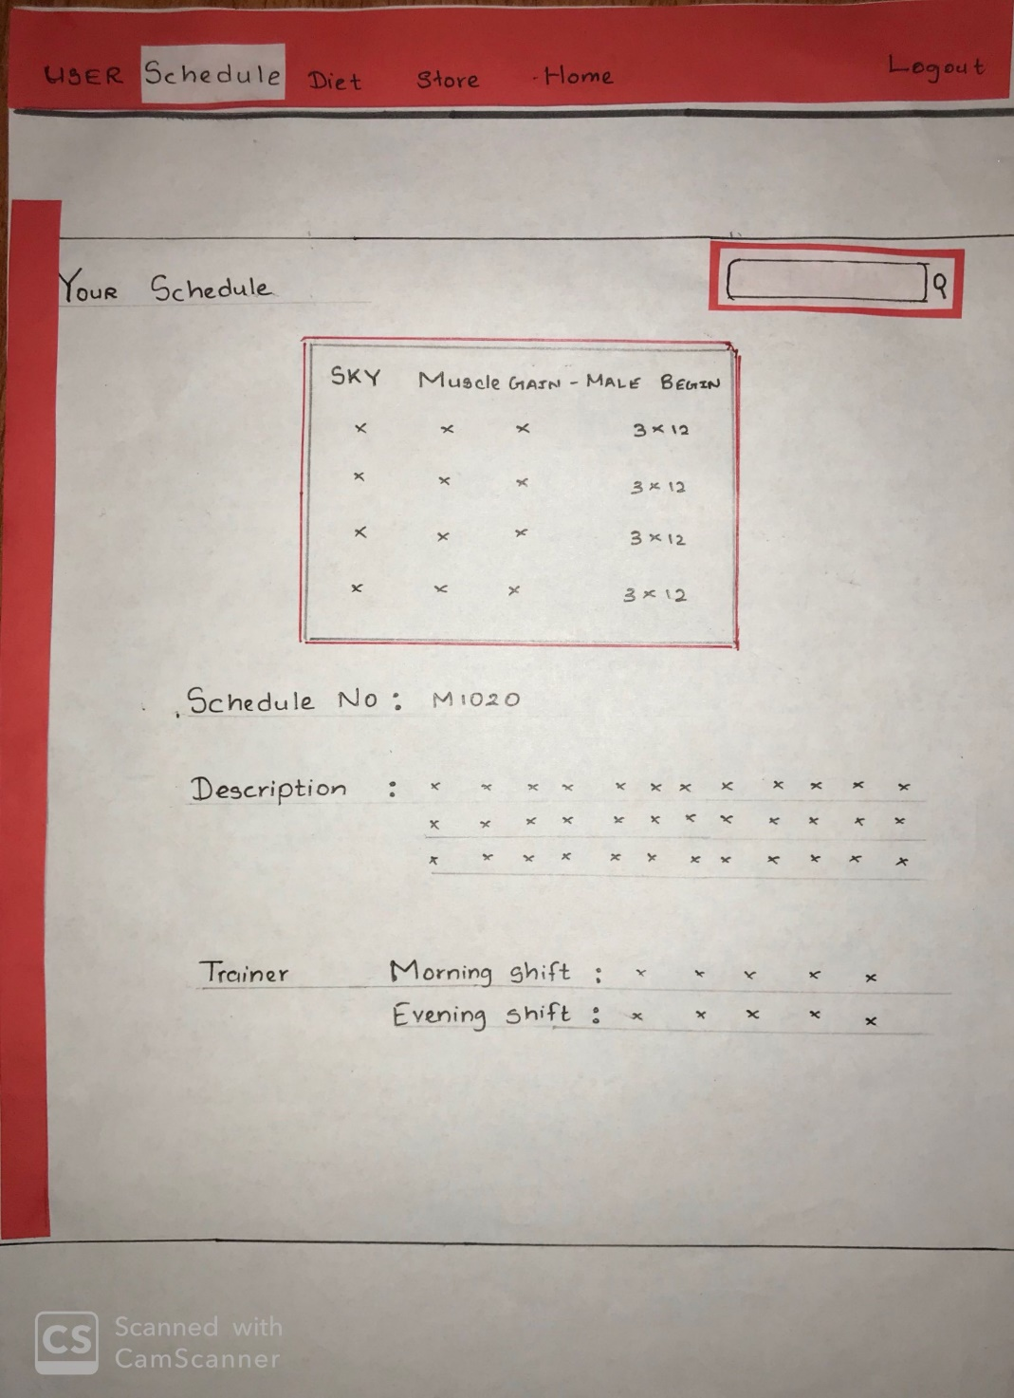

After selecting a schedule if the customer visits this page using the schedule tab he will be informed with the selected schedule. It has all the necessary information about the schedule.

Along side this page there is a search bar in which we can search the schedules.

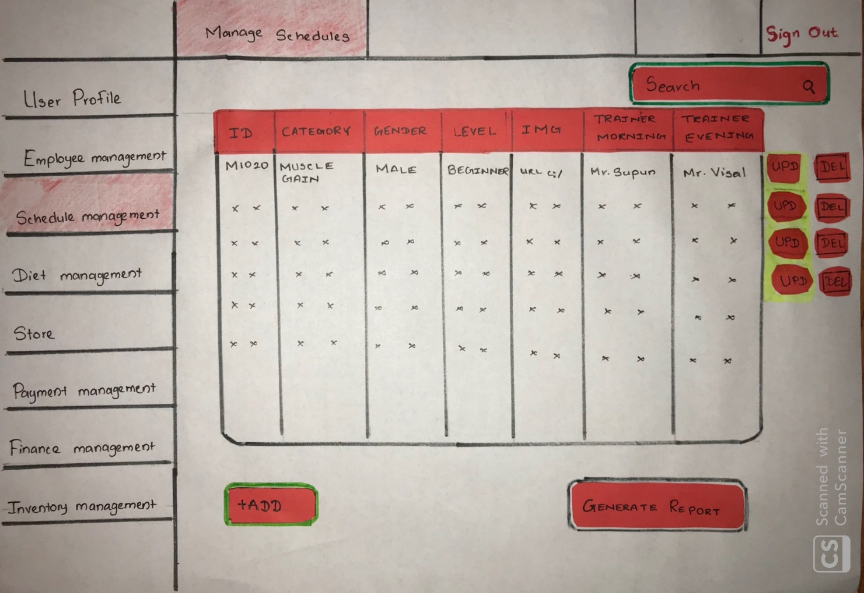

This page Belongs to The Admin Side this page contains all the related task for CRUD functionality.

It consists with a search bar which is capable of searching the schedules and the searched items will be displayed in the table.

Every single item has a **update** and a **delete** button.

If we delete a schedule which is being used by a member the system will prompt a warning message.

At the bottom of the page we are provided with the **Add** button which is suitable for adding new functions.

The page also contain a Generate Report which will generate an overall schedule report.

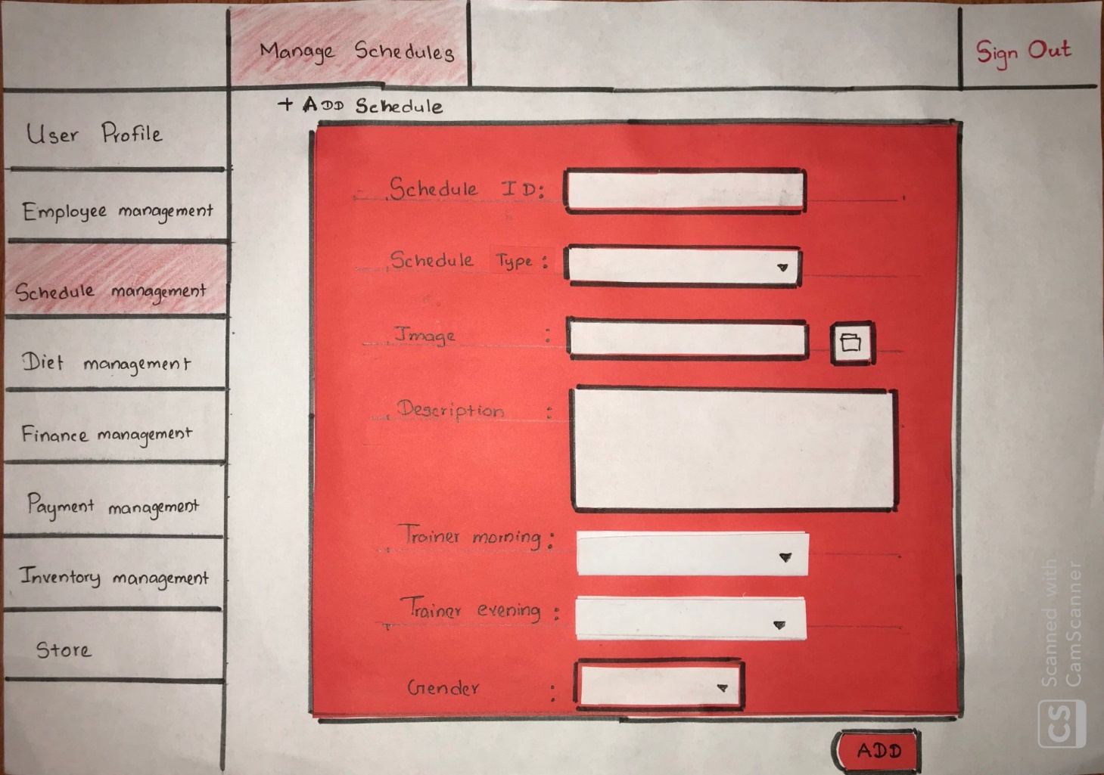

This UI belongs to the page which is used to Add a new Schedule to the system. This contains a form

with required credentials with proper validation. After pressing Add button the Admin can add a new schedule on the required category using the credentials.

The same page is displayed when Updating the schedule where the Add button changes to Update in which we can update the required schedule with the required field.

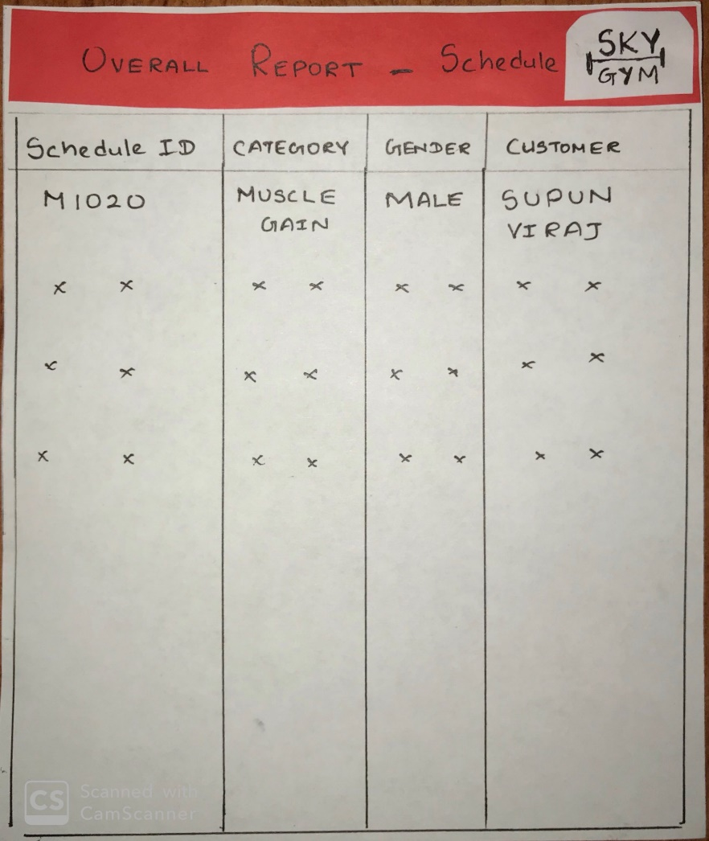

This is the Overall Report that is generated with the use of the system which can be printed afterwards.

This Report is generated using the Database which stores the schedules.

The Report contains information such as Schedule ID, Category, Gender and the Name of the member using that particular schedule.